Operations Management

Section A: Answer all FIVE questions. Each question is 10 marks (total 50 marks)

Question 1

What is the difference among Just-In-Time (JIT), and Lean Operations?

Question 2

What is the purpose of establishing control limits for forecast errors?

Question 3

With an example, briefly explain about Master Production Schedule (MPS)

Question 4

Name three advantages and three disadvantages of standardization

Question 5

What are the two important objectives of inventory control?

Section B: Answer ALL FOUR questions. Each question is 12.5 marks. (total 50 marks)

Question 6

The operations manager of a manufacturing firm has gathered the following information for the product A.

 | Forecast
Month 1 | 1800
Month 2 | 1100
Month 3 | 1600
Month 4 | 900

Beginning inventory = 0 unit
Stockout cost =$150 per unit
Inventory holding cost = $40 per unit at the end of month
Hiring employees = $40 per unit
Terminating employees = $80 per unit
Subcontracting cost = $60 per unit
Unit cost on regular time = $30 per unit
Overtime cost = $15 extra per unit
Capacity on regular time = 1800 units per month

Using the above information develop an aggregate plan using a Level strategy. Calculate the total cost.

Question 7

An operations manager is attempting to monitor a filling process that has an overall average of 705 cc. The average range is 6 cc. if you use a sample size of 10, what are the upper and lower control limit for the mean and the range? Is the process under control? Explain.

Question 8

A manufacturer produces metal disc used in car engine. A quality inspector took three samples, each with five observations, of the diameter of the metal discs. The mean of the diameter for each sample are given in below table:
Sample | 1 | 2 | 3
Mean in cm | 23.98 | 24.25 | 23.11

All values are in centimetres. Use this information to obtain three-sigma (i.e., z = 2) control limits for means of diameters. It is known from previous experience that the standard deviation of the process is 3 cm.

a. Use this information to obtain two-sigma (i.e., z = 2) control limits for means of future times.
b. Is the process of producing the metal disc normal? Why?
c. For what percent of the discs the diameters is less than 25.18 cm

Question 9

A car manufacturer has the following demand to meet for custom manufactured fuel injector parts. The holding cost for that item is $0.75 per month and each setup costs $150. No initial inventory. Complete material requirement planning (MRP) Calculate the order quantity by use of EOQ model. Compute the total inventory cost. Lead time is 2 months.

Month | 1 | 2 | 3 | 4 | 5 | 6 | 7
Gross Requirement | 200 | 150 | 200 | 150 | 100 | 150 | 250

<<End of Document>>

Formula List
$$EOQ=\sqrt{{2SD}/H} Q\left[1-\frac{d}{p}\right]$$
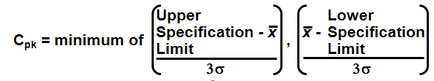
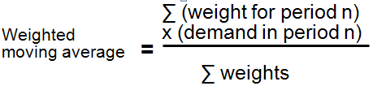
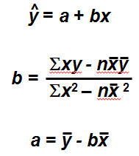
$$ROP=d*L EPQ=\sqrt{\frac{2SD}{H[1-\left(d/p\right)]}}$$

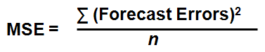

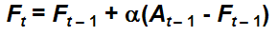
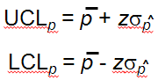
$$UCL=D_{4}\overline{R} LCL=D_{3}\overline{R}$$
$$LCL=\overset{̿}{X}-A_{2}\overline{R} UCL=\overset{̿}{X}+A_{2}\overline{R}$$
$UCL=\overset{̿}{X}+Zσ_{\overline{X}}$ $LCL=\overset{̿}{X}-Zσ_{\overline{X}}$

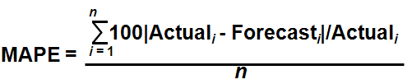
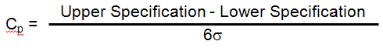

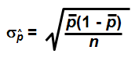

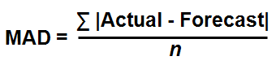

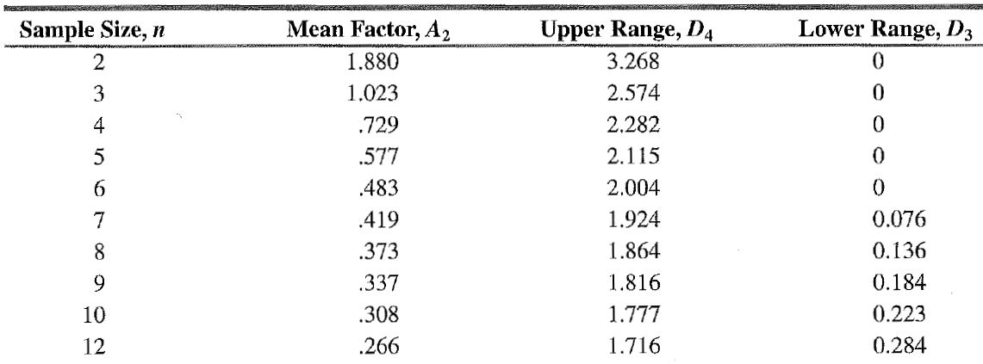

Areas for the Standard Normal Distribution (continued)

